Group Name- Webstars

Group Members:-

Gandhali Atre

Khushan Adatiya

Nishi Yeotikar

SOA Architectural Diagram

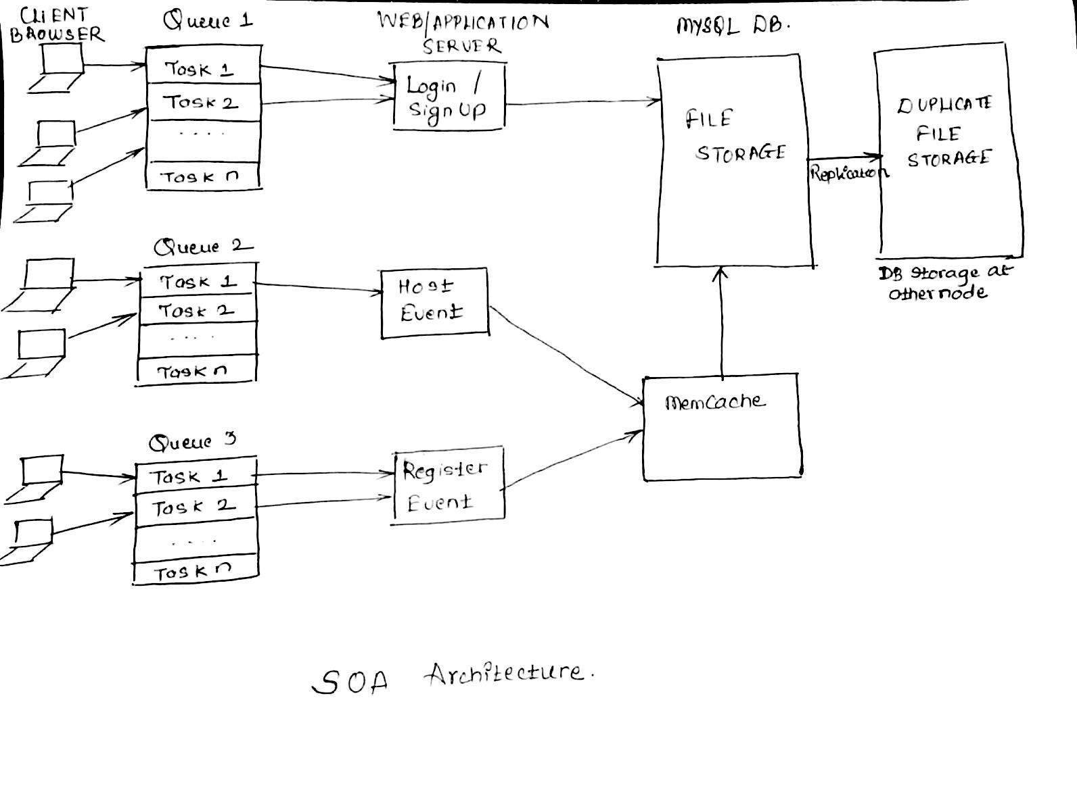

This is a Dallas-Community Events site which provides details about the events being hosted by different communities in and around Dallas. It will provide 3 core services -

**Login/Sign up** - Site will provide Sign up functionality for non members and login functionality for members. This will be implemented using the idea of Authentication, and encrypted client server communication.

**Hosting events** - Site members can create events by posting appropriate event details, timings and venues using the designed interfaces. Event postings will be approved by the Admin.

**Register for the events** - Registering for events can be done only by site members. Registering for the event will include along with it the Payments functionalities. Users can look around for the events - Site members and non - members can view the events. Events can be filtered depending upon different criteria's. Filtering can be provided in the GUI.

**Functionalities**:-

* Site will allow to post events by members only after approval from Admin.
* Admin will take care of the permissions to be allowed to the members of the site i.e core idea of Authorization.
* Members of the site will have default access/permissions to View events, Register for events.
* Site will also provide other functionalities like giving notifications to the members for the events registered and also similar kind of events they would be interested in.
* Members can get some coupons from the site, which will have coupon codes, that may be used further ahead in getting discounts for registrations and may be food coupons available for the event.
* Registered event members can post transport pick up service request. Members interested in Car Pool sharing or pick up service can post about it and spread the word.
* Events posted can be tracked using Track Progress mechanism. Group member can track information regarding the event posted by him/her to understand number of people attending the event, arrangements required to accommodate those many people.
* Users can sign up for membership. Membership will be offered on Monthly, Annual basis. These kind of members will receive discounts and special offers depending on type of membership enrolled for.
* Functionality to track users history of events attended or registered will be provided.